Open chat-ui folder then write on address bar *cmd* and hit *enter*

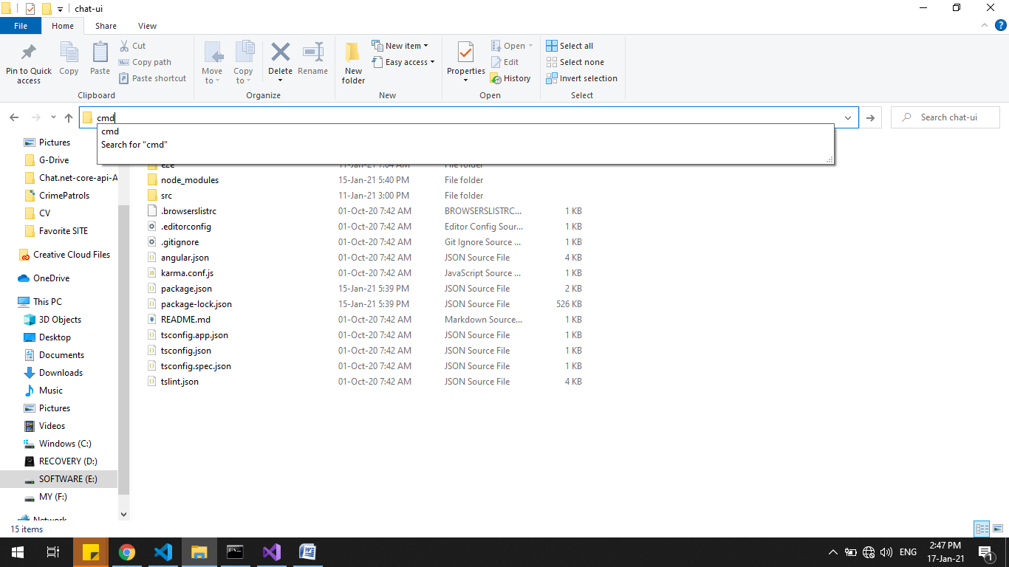fig: how to open chat-ui

Command prompt open

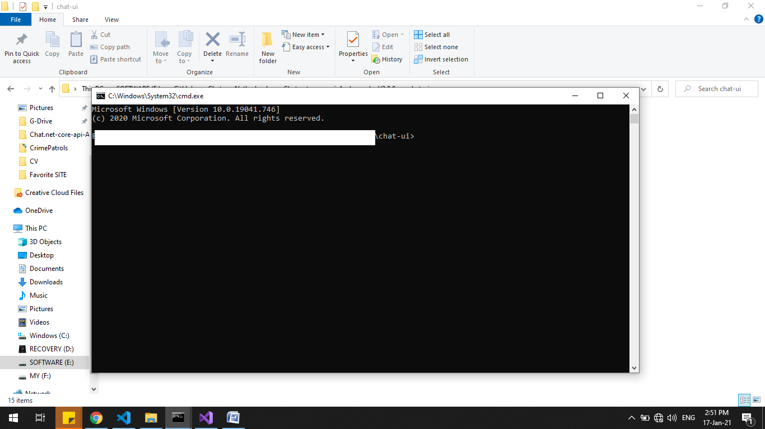fig: cmd open .

then write command *npm i*

It needs some time to install note-module in your angular app

After installation write comman *ng s*

Now you can open 2 browsers and write on address bar [*http://localhost:4200*](http://localhost:4200)